Git work flow:

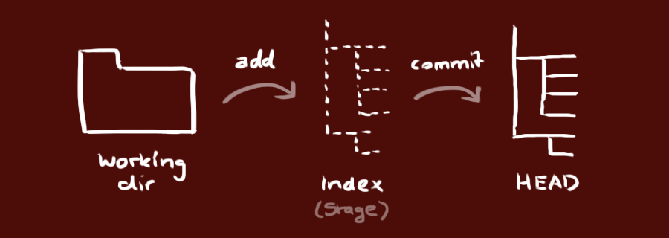

Typical Workflow are as follows:

1.Get local copy of code

2.Create a branch

3.Edit files

4.Add and commit changes to local machine

5.Get back in sync with changes commited by others

6.Push branch to remote git repository

7.Merge local branch into local master

8.Push local master to remote git repostiory